# Create a New Database

1. Open FileMaker Pro.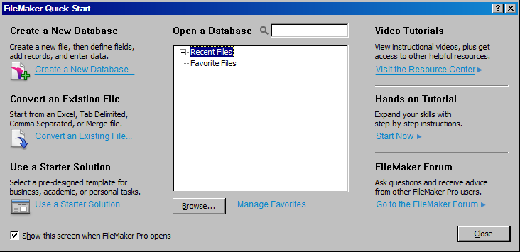
2. Close FileMaker Quick Start.
3. Click File Menu
4. Select New Database

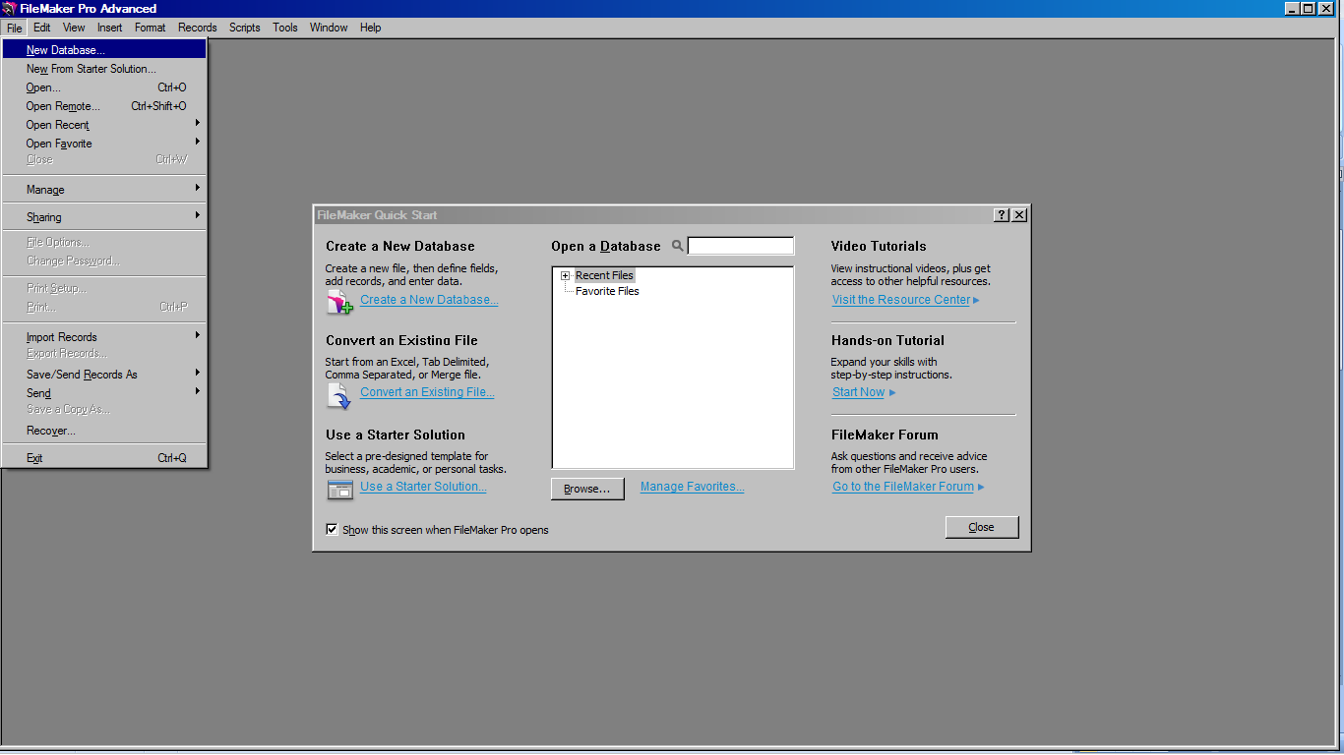

1. File name: **sample_database**

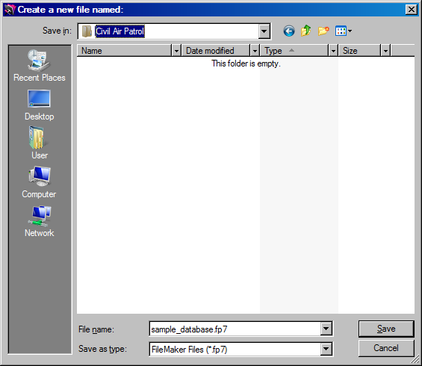

1. Click Save.

# Create a Table

1. File/Manage database.

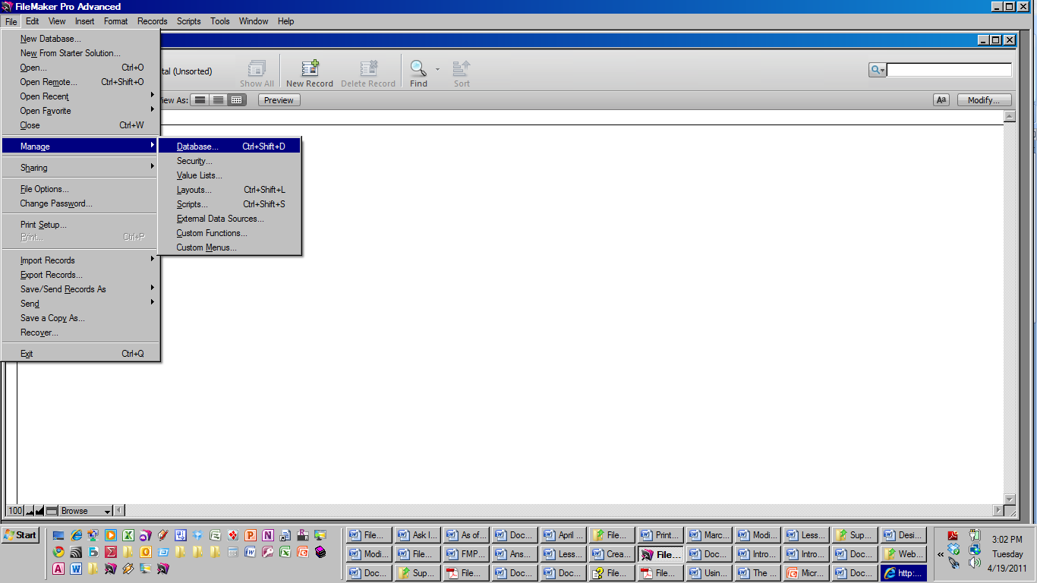

1. Tables tab.
2. Select table to be deleted.

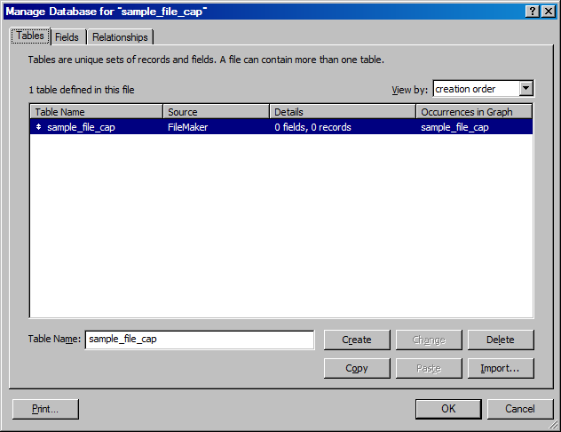

1. Click Delete button.
2. Click Delete on message box.

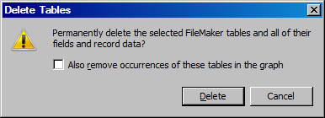

1. Type table name (customers), then click create button.

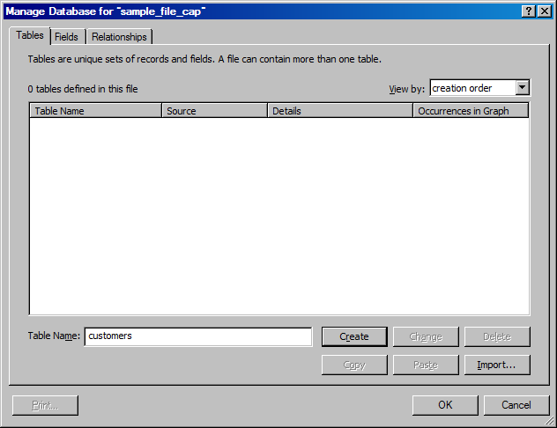

# Create Fields

NOTE: Field names should be all lower case letters, with no spaces (use underscore between words, i.e. name_last)

**To Create the Primary Key:**

1. Click **Fields** tab
2. Type: **pkey_customers** (name)
3. **Text** type is already selected
4. Click **Create** button.

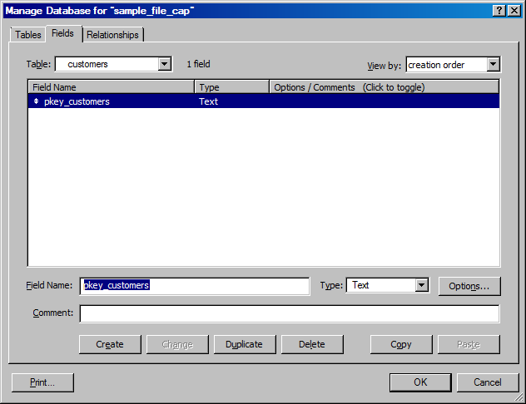

1. Options button/auto-enter tab
2. Click Serial number option button
3. Change to # 101
4. Next value/Increment by 1
5. Prohibit modification of value during data entry

(So that the primary key for a record cannot be changed)

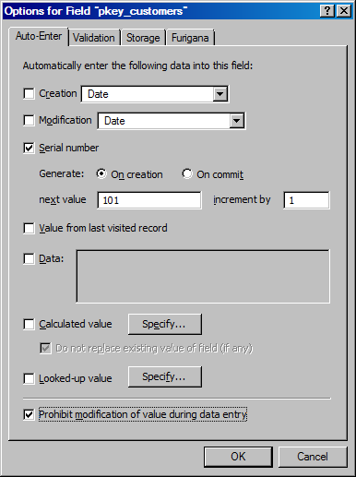

1. Type all other field names and select proper field types, making sure to click CREATE button for each one:

|  |  |
| --- | --- |
| **FIELD NAMES** | **FIELD TYPE** |
| **title** | **Text** |
| **name_first** | **Text** |
| **name_last** | **Text** |
| **name_middle** | **Text** |
| **name_suffix** | **Text** |
| **date_of_birth** | **Date** |

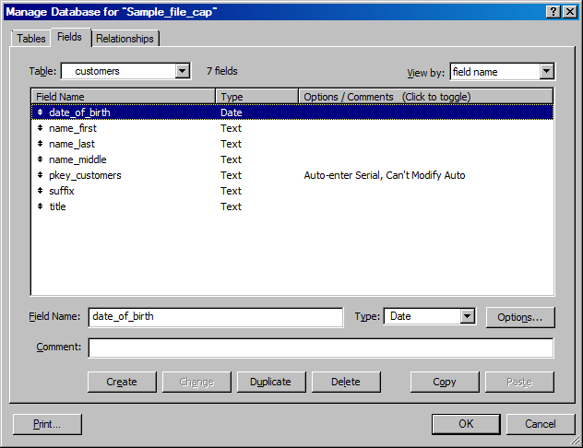

1. click OK